Using digital tools to enhance language learning
To develop speaking and listening skills
- TubeChop www.tubechop.com
  - Staff only
- EDpuzzle www.edpuzzle.com/
  - Available for students K-12
  - Requires parental consent for children under 13 years old
- Voki www.voki.com
  - Available for students K-12
  - Teachers may wish to create a class account for younger students and share the login information with students
To build vocabulary and script
- lino it http://en.linoit.com/
  - Available for students in Years 9-12
- Wordle http://www.wordle.net/
  - Available for students K-12
- Quia www.quia.com
  - Available for students K-12
  - Teachers may wish to create an account and then an online class in which their students can enrol and play the interactive quizzes
- Quizlet www.Quizlet.com
  - Available for students K-12
  - Requires parental consent for children under 13 years old
  - For students under 13, Quizlet only offers limited features and website accessibility and removes some social features
- Kahoot https://getkahoot.com/
  - Available for students K-12
- Socrative http://www.socrative.com/
  - Available for students K-12
  - Teachers create a ‘room’ and students can login to that room to complete quizzes
  - Recommended for students over 11 years old
- Formative https://goformative.com/
  - Available for students K-12
- Flipquiz http://flipquiz.me/
  - Available for students K-12
  - Students aged between 13-18 years old may use the site, however a parent or guardian must sign up on their behalf
To develop writing skills
- Animoto www.animoto.com
  - Available for students K-12
- Toondoo www.toondoo.com
  - Available for students K-12
  - Not for use by students under 13 years old
- Padlet www.padlet.com
  - Available for students K-12
National resources
- Scootle www.scootle.edu.au
- Language Learning Space www.lls.edu.au
Collaborative tools
- Google Apps for Education http://staff-googleapps.education.nsw.gov.au
- Microsoft 365 https://education.microsoft.com/GetTrained/Teacher-Academy-Office-365
- Miro https://miro.com/

Apps for languages teachers
App icon | App description
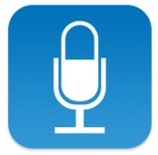 | QuickVoice Recorder – recording students’ speaking exams or create listening tasks  Free for iPhone and iPad  https://itunes.apple.com/au/app/quickvoice-recorder/id284675296?mt=8
Voice recorder Pro – best app for recording voice
Free for iPhone and iPad
https://itunes.apple.com/au/app/voice-record-pro/id546983235?mt=8
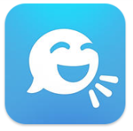 | Tellagami – talking full body avatar, choices for hair, skin, library of backgrounds or use own background image  Free for iPhone and iPad  https://itunes.apple.com/au/app/tellagami/id572737805?mt=8
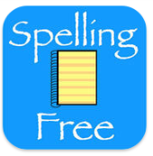 | Spelling Notebook Free – create word lists, record the clue (in language) and test themselves on vocab meanings  Free for iPhone and iPad  https://itunes.apple.com/au/app/spelling-notebook-free/id461225509?mt=8
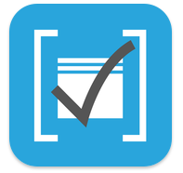 | Flashcards – create and share flashcards  For iPhone and iPad free  https://itunes.apple.com/au/app/flashcards*/id403199818?mt=8
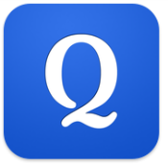 | Quizlet – create or access study lists  Free for iPhone and iPad  https://itunes.apple.com/au/app/quizlet-flashcards-study-tools/id546473125?mt=8
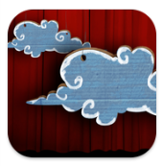 | Puppet Pals HD – create movies with animation and sound  Free for iPad  https://itunes.apple.com/au/app/puppet-pals-hd/id342076546?mt=8
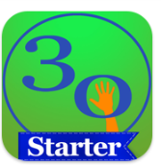 | 30hands Starter: Create and Show what You Know – create a slideshow of images with sound recording  $0.99 (November 2017) for iPhone and iPad  https://itunes.apple.com/au/app/30hands-starter-create-show/id605013231?mt=8
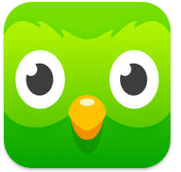 | Duolingo – learn Languages for free  Free for iPhone and iPad  https://itunes.apple.com/au/app/duolingo-learn-languages-for/id570060128?mt=8
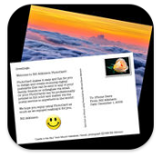 | Photocard by Bill Atkinson – personalised postcards  Free for iPhone and iPad  https://itunes.apple.com/au/app/photocard-by-bill-atkinson/id333208430?mt=8
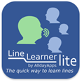 | LineLearner lite – to learn lines of a dialogue (5 lines each), good for independent practice of dialogue  Free for iPhone and iPad  https://itunes.apple.com/au/app/linelearner-lite/id370419861?mt=8
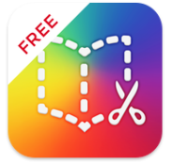 | Book Creator Free – make books with photos, video and sound  $7.99 (November 2017) for iPad  https://itunes.apple.com/au/app/book-creator-free-make-books/id661166101?mt=8
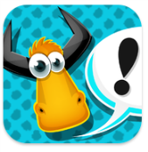 | YAKiT kids – turns images/photos into animated characters with 15 seconds sound recording  Free for iPhone, iPad, and iPod touch  https://itunes.apple.com/au/app/yakit-kids/id794546203?mt=8

Apps for teachers
App icon | App description
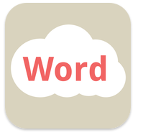 | Word clouds by ABCYa.com – allows you to create a Wordle to be used as a background  Free (for a limited time, November 2017) for iPhone and iPad  https://itunes.apple.com/au/app/word-clouds-by-abcya.com/id823682295?mt=8
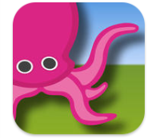 | Greenscreen by Do Ink – green screen, can put video in background  $4.49 (November 2017) for iPhone and iPad  https://itunes.apple.com/au/app/green-screen-by-do-ink/id730091131?mt=8
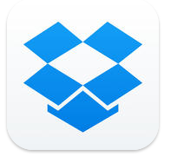 | Dropbox – allows you to access the Dropbox you create on a computer and easily transfer information, images, documents from computer to iPad  Free for iPhone and iPad  https://itunes.apple.com/au/app/dropbox/id327630330?mt=8
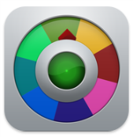 | Decide Now! – paid version allows labels to be changed on spinner  $0.99 (November 2017) for iPhone and iPad  https://itunes.apple.com/au/app/decide-now!/id383718755?mt=8
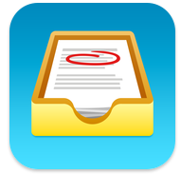 | Showbie – assign, collect and review student work  Free for iPhone and iPad  https://itunes.apple.com/au/app/showbie-paperless-classroom/id548898085?mt=8
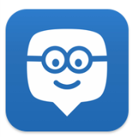 | Edmodo – collaborating tool for teachers and students  Free for iPhone and iPad  https://itunes.apple.com/au/app/edmodo/id378352300?mt=8
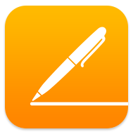 | Pages – word processor  Free for iPhone and iPad  https://itunes.apple.com/au/app/pages/id361309726?mt=8
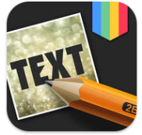 | Free Text on Photo – add text to photos  Free for iPhone and iPad  https://itunes.apple.com/au/app/free-text-on-photo-99-fonts/id725683923?mt=8
YouTube Capture – film and share videos, easy, fast recording
Free for iPhone and iPad
https://itunes.apple.com/au/app/youtube-capture/id576941441?mt=8
i-nigma – enables camera to read QR codes and barcodes
Free for iPhone and iPad
https://itunes.apple.com/au/app/i-nigma-qr-code-data-matrix/id388923203?mt=8
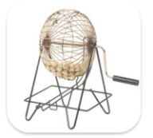 | Bingo Number Generator – a portable bingo cage  Free for iPhone and iPad  https://itunes.apple.com/au/app/bingo-number-generator/id607450375?mt=8
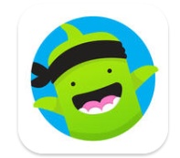 | ClassDojo – classroom management  Free for iPhone and iPad  https://itunes.apple.com/au/app/classdojo/id552602056?mt=8
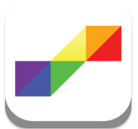 | Autism Apps – allows you to find apps to help with students with special needs  Free for iPhone and iPad  https://itunes.apple.com/au/app/autism-apps/id441600681?mt=8

