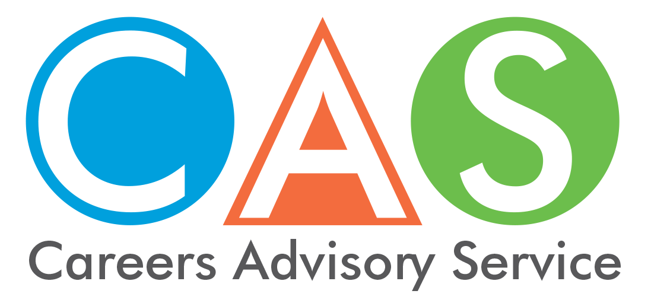

15. Higher Education Loan Program (HELP) and other student loans
A Commonwealth supported place (CSP) is a subsidised higher education enrolment. CSPs are available at all public universities (and some private higher education providers in national priority areas like nursing and education). A CSP means the government helps by paying part of the fees directly to the university. Students are required pay the remainder of the fees which is known as the ‘student contribution amount'.
The Australian Government’s Higher Education Loan Program (HELP) provides financial assistance through different HELP schemes to assist you to pay the student contribution amount and other tuition costs. The right loan for you will depend on your circumstances, eligibility and where you want to study.
VET Student Loans provide similar loans to students studying approved higher level vocational education and training (VET) courses.
The Australian Government StudyAssist website has full details about eligibility, student contributions and repayment. Note that there are citizenship eligibility requirements to be met.
Both programs are administered by the Australian Government Department of Education and Training. Debts and repayments are managed by the Australian Taxation Office (ATO).

HECS-HELP
HECS-HELP is a loan scheme for eligible students enrolled in Commonwealth supported places to pay their student contribution amounts. It cannot be used for additional study costs such as accommodation or text books.
- The student contribution amount is calculated on the number of units the student studies, the equivalent full-time student load (EFTSL) of each unit, and the price band to which the unit belongs. The bands reflect both the cost structure of the course and future earnings potential.
- A student can elect to pay the student contribution up-front rather than deferring the amount as a HELP loan.

FEE-HELP
- FEE-HELP assists eligible full fee-paying students to pay their tuition fees. These students are usually studying through approved private providers or undertaking postgraduate courses for which there is no Commonwealth supported place.
- There is a lifetime limit on FEE-HELP debt. This includes all FEE-HELP and VET Student Loans debts.
- There is a 25% loan fee, which is added to the balance of the loan, but does not count towards the FEE-HELP debt limit. The loan fee only applies to undergraduate students and courses; it is not paid by full-fee postgraduate and research students.

OS-HELP (overseas)
- OS-HELP loans assist eligible Commonwealth supported students undertaking part of their studies overseas. An OS-HELP loan can be used for airfares, accommodation and other costs of overseas study.
- OS-HELP loans are paid by the Australian provider to the student. The provider is then reimbursed by the Government and a HELP debt created.
- Students may receive one loan per six-month study period and can access a total of two OS-HELP loans over their lifetime.
- You should contact the student administration area of your provider for more information.

SA-HELP (student amenities)
- SA-HELP assist eligible students to pay for all or part of their student services and amenities fee.
- A capped student amenities fee can be charged by a higher education provider and can be made compulsory.
- Students can borrow this amount along with their other HELP loans or borrow only this amount.

VET Student Loans
- These loans assist eligible students enrolled in higher level VET courses to pay their fees.
- Available only for eligible diploma, advanced diploma, graduate certificate and graduate diploma courses that are provided by an approved course provider.
- Loans are available up to a capped amount for each course. Providers may charge above the cap for a course, in which case students will be expected to pay the difference.
- There is a lifetime limit on FEE-HELP debt. This includes all FEE-HELP and VET Student Loans debts.
- There is a 20% loan fee, which is added to the balance of the loan, but does not count towards the FEE-HELP debt limit. Students who are subsidised by a state or territory government do not pay the loan fee.
- Students will be required to demonstrate they are progressing through the course. Students are required to log on twice during the year and acknowledge that they accept the loan they are receiving.
- More information is available in the VET Student Loans information booklet.

Paying back your loan
- HELP and VET Student Loans provide interest-free loans, but the outstanding amount is indexed annually by the Consumer Price Index (CPI).
- All HELP and VET Student Loans debts are managed by the Australian Taxation Office. An individual commences repaying their loan debt when their taxable income reaches the repayment threshold.
- The rate at which the HELP debt is repaid rises according to taxable income, up to the value of the debt.

Student Start-up Loans
- Available for eligible new recipients of Youth Allowance, Austudy and ABSTUDY studying a Student Start-up Loan approved course.
- The loans are paid in two half-yearly instalments.
- Repayment arrangements are the same as for HELP.

Trade Support Loans
- Trade Support Loans are intended to assist apprentices with everyday costs while they complete their apprenticeship.
- Payments are made monthly in arrears.
- Loans are indexed in line with the CPI.
- HELP debt and Student Start-up Loan debt are repaid before Trade Support Loan debt.

© 2018 NSW Department of Education

