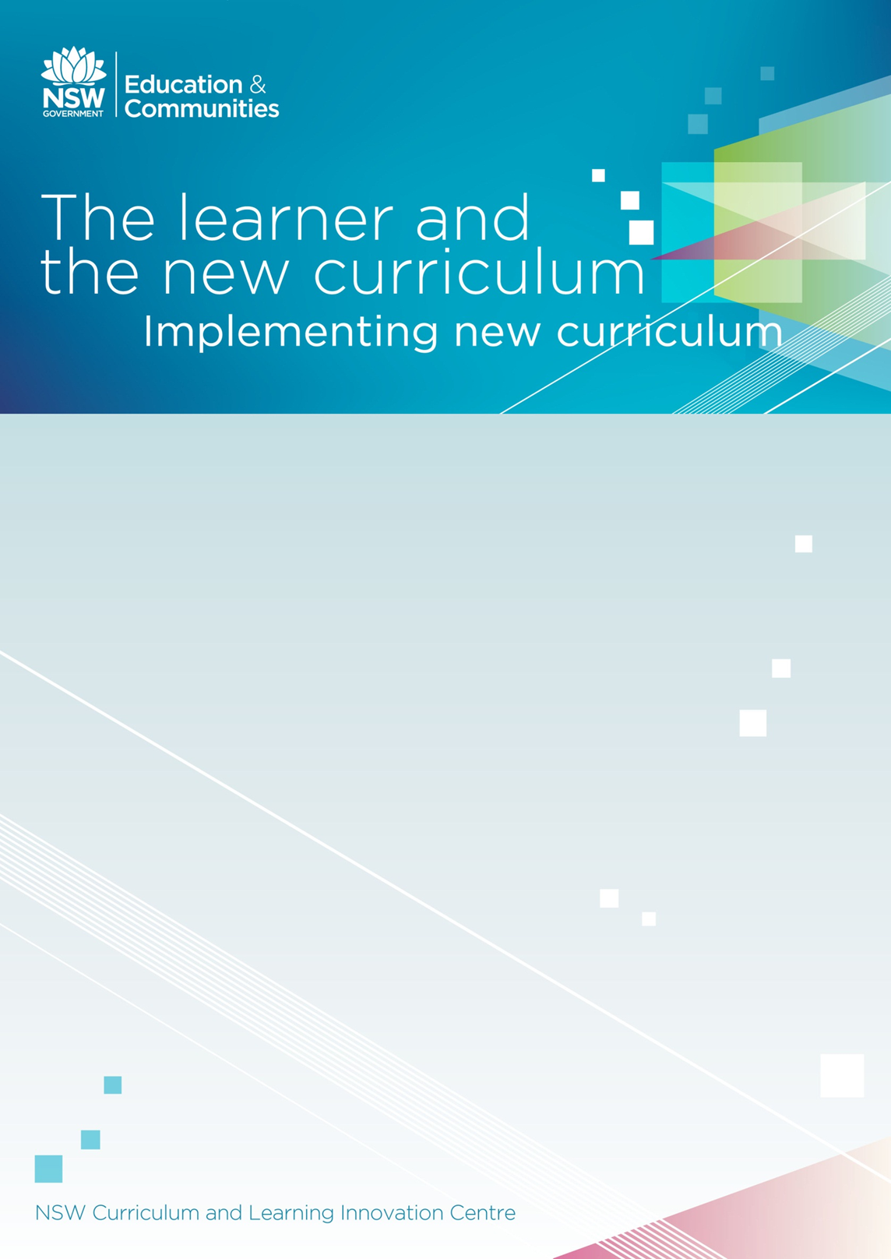

Activity Booklet

Activity 1: Learning across the curriculum
Consider a complex issue such as climate change, poverty or bullying, or another issue relevant to your school.
Complex issue chosen:
Write a short statement about how the key learning area of your choice helps learners understand the issue you have chosen.

Write a short statement about how up to three of the areas of Learning across the curriculum help learners understand the issue you have chosen.  Areas include:  - Critical and Creative Thinking  - Personal and Social Competence  - Ethical Understanding  - Information and Communication Technologies  - Intercultural Understanding  - Literacy  - Numeracy  - Difference and Diversity  - Civics and Citizenship  - Work and Enterprise  - Aboriginal and Torres Strait Islander histories and Cultures  - Asia and Australia’s relationship with Asia  - Sustainability and Environment | Learning across the curriculum area 1:
 | Learning across the curriculum area 2:
 | Learning across the curriculum area 3:

Activity 2: The context of learners
Issues and factors influencing my students’ lives

Part A: Think about a class you are teaching and the students in that class. Write a list of words describing issues and factors that influence your students’ lives in the first column of the table.

Part B: Modify your list of words that reflect the world in which your students live. Write your modifications in the second column of the table and save.
 | Part A | Part B
1
2
3
4
5
6
7
8

Activity 3: Diversity

The revised BOS NSW syllabuses provide a new opportunity for me as an educator to cater for my students as modern learners in a diverse classroom.
In light of what you have read,what will be the impact of student diversity onteaching and learning in your classroom?

Activity 4: Capacities needed by today’s learners
Consider the capacities you have viewed. Write a list of the capacities you most want to develop in the children and young people you teach.
Capacity | What drives the need for this capacity?

Activity 5: How students learn

Consider what you have read and seen in this tab in order to complete this activity.
- Select one of the highlighted strategies from this tab, for example, scaffolding.

- Describe one action you would take in your classroom that has a positive impact on student learning.

If you would like to explore this subject in more detail, read The nature of learning: using research to inspire practice (OECD 2010).

Course deliverable: Profile
The materials in this course have addressed:
- how new curriculum will meet the needs of learners
- the context of learners
- diversity of learners
- capacities needed by today’s learners
- how students learn.
To complete this course, respond to the statements below as you reflect on one of your classes.
Class:
- The context of learners – list important factors in your students’ lives.
- Diversity of learners – identify the diverse needs of your students.

- Given your school’s situation, identify two or three capacities your students need to develop.

- Choose one of the capacities you have identified in question 3. Use your knowledge about how students learn and describe how you could use the new curriculum to help your students develop that capacity.

- Identify one thing you now know about how students learn.

Describe how the reflection above will influence your teaching practices.

Course: The learner and the new curriculum

Teacher Name: __________________________________

School: ___________________________________________ ☐ I am a new scheme teacher

Pre-course checklist

☐ MyPL@Edu registration
☐ Consultation with school Professional Learning Committee / Principal

Activities checklist

Activities
☐ Activity 1: Learning across the curriculum
☐ Activity 2: The context of learners
☐ Activity 3: Diversity
☐ Activity 4: Capacities needed by today’s learners
☐ Activity 5: How students learn

Deliverables checklist

Deliverable
☐ Class profile and reflection statement on teaching practice

Post-course checklist

☐ Collegial collaboration – actively engaged in discussion and collaboration with teaching colleagues, relevant consultants, facilitators and supervisors during the course.
☐ A wide variety of resources were consulted to inform the participant of current and up to date practices in implementing the Australian Curriculum to enable completion of the course.
☐ MyPL@Edu evaluation must be completed for successful accreditation.
☐ Institute of teachers evaluation must be completed for successful accreditation.

Supervisor sign-off

I certify that _______________________________ has completed the above requirements for the enter course name course.

Signed: ___________________________________ Date: _____________

Position: _________________________________________________________________

