Assessment Task – Solar Panels & Swimming Pools

Year 11 Mathematics Standard – Measurement
This document references the Mathematics Standard Stage 6 Syllabus © 2017 NSW Education Standards Authority (NESA) for and on behalf of the Crown in right of the State of New South Wales.
Assessment type: Research task on solar panels output efficiency and measurement calculations, including surface area, volume and trapezoidal rule.
Stage 6
Due Date:

Outcomes
- MS11-3 Solves problems involving quantity measurement, including accuracy and the choice of relevant units
- MS11-4 Performs calculations in relation to two-dimensional figures
- MS11-9 Uses technology to investigate, organise and interpret information in a range of contexts
- MS11-10 Justifies a response to a given problem using appropriate mathematical terminology and/or calculations.

Learning across the curriculum

Cross-curriculum priorities
☐ Aboriginal and Torres Strait Islander histories and cultures
☐ Asia and Australia's engagement with Asia
✓ Sustainability

General capabilities
✓ Critical and creative thinking
✓ Ethical understanding
✓ Information and communication technology capability
☐ Intercultural understanding
✓ Literacy
✓ Numeracy
✓ Personal and social capability

Other areas of learning
☐ Civics and citizenship
☐ Difference and diversity
✓ Work and enterprise

Task

Context
Mathematics is an essential tool to analyse sustainability issues including predicted energy use and how we can reduce it using alternative energy sources such as solar cells. Through measurement and the reasoned use of data, we can predict and evaluate our impact on energy use, and develop a deeper appreciation of the use of Earth’s resources.
In this task, you will utilise your understanding of the various measurement applications, including your knowledge of surface area, volume and capacity, to design a swimming pool. You will also be required to research the efficiency of solar panels and calculate energy usage based on the size of panels and the output of energy.

Task
- When installing solar panels on the roof of a building, it is important that they face a specific direction and have a recommended tilt angle to maximise their energy output. Research the optimum aspect and tilt angle if a set of solar panels were installed in Sydney NSW. Write up to 5 sentences about your findings, making sure that you reference your source of information.
- Using Google Earth (https://www.google.com/earth/), locate the building that has the following coordinates 33 49’ 42.2”S, 151 05’ 04.3”E.[Guide to using Google Earth: https://drive.google.com/open?id=0B-USPAJXwSjsOWpqaG5TS0stU0k]
- Measure the dimensions of the roof of the building, using the Ruler Tool correct to the nearest 0.5m.
- Calculate the area of the roof you have just measured.
- A single solar panel has the dimensions of 1.6m x 80cm. Calculate the area of one solar panel in m2, and hence, how many panels could theoretically be placed on the roof?
- In order to operate effectively, the solar panel installer has informed you that there must be a 5cm space between each row of panels, as shown below. Given this new information, draw a diagram of the layout of your panels, and determine how many full panels can actually fit on the roof.
- List at least two reasons why your answer to part (c) and part (d) are not the same.
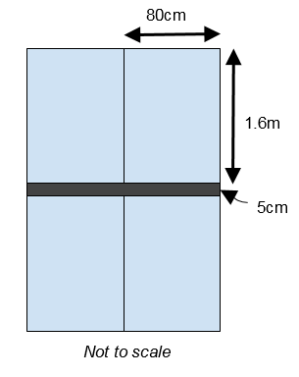
- The solar system installed in question 2 is a 0.72 Megawatt system.
- Covert 0.72MW to kW.
- Using the table below, predict how many kWh this system will produce each day for a building located in Sydney.
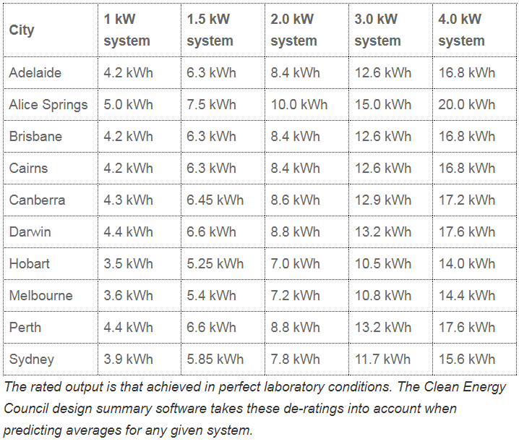
Average Daily Production table reproduced with permission from Clean Energy Council (http://www.solaraccreditation.com.au/consumers/purchasing-your-solar-pv-system/how-solar-pv-works.html)
- The building from question 2 and 3 uses three fifths of the energy produced by the solar panels and feeds the remaining energy back to the grid. An electricity provider is willing to buy back power at the rate of 6 cents/kWh. How much money, in dollars, will the building receive from the provider in the month of January?
- Johnson High School is about to install a pool. The shape of the pool is shown on the diagram below.
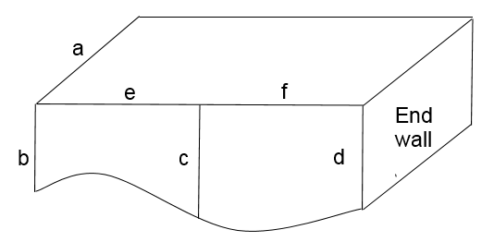
- Select the dimensions of the pool for the following lengths (a, b, c, d, e, and f). Your dimensions should reasonably reflect the measurements of real swimming pools.
- Calculate the total surface area of the end walls.
- Use the trapezoidal rule to calculate the surface area (with 2 applications) of the sides of the pool.
- Calculate the cost of the four side walls if they are to be tiled at a cost of $50p/m².
- Calculate the capacity of the pool, when it is completely full, in kL, correct to one decimal place.
- Johnson High School is located in Cairns. It has been estimated that the pool will consume approximately 0.01 kWh/L each year. The school has already installed a 4kW solar system to supply the electricity demands of their new pool.
- Using the table from question 3, will the solar system be able to supply enough energy to meet the requirements of the swimming pool? Justify your answer with suitable calculations.
- Outline two advantages of using solar panels to supply some, or all, of the energy requirements of the pool.

Marking guideline/rubric
Outcome | A | B | C | D | E
MS11-3  Questions 3a, 4a, 5d, 5e | Student uses correct units and correct unit conversions in all calculations.  Student gives answer to all questions with correct rounding off as required in the question.  Student gives answer to all questions to a reasonable level of accuracy if the accuracy required is not stated.  Student justifies the level of accuracy chosen for all questions where the accuracy required is not stated. | Student uses correct units and correct unit conversions in all calculations.  Student gives answer to all questions with correct rounding off as required in the question.  Student gives answer to most questions to a reasonable level of accuracy if the accuracy required is not stated.  Student justifies the level of accuracy chosen for most questions where the accuracy required is not stated. | Student uses correct units and correct unit conversions in most calculations.  Student gives answer to most questions with correct rounding off as required in the question.  Student gives answer to most questions to a reasonable level of accuracy if the accuracy required is not stated.  Student justifies the level of accuracy chosen for most questions where the accuracy required is not stated. | Student uses correct units and correct unit conversions in some calculations.  Student gives answer to some questions with correct rounding off as required in the question.  Student gives answer to some questions to a reasonable level of accuracy if the accuracy required is not stated.  Student justifies the level of accuracy chosen for some questions where the accuracy required is not stated. | Student uses correct units and correct unit conversions in limited or no calculations.  Student gives answer to limited questions with correct rounding off as required in the question.  Student gives answer to limited or no questions to a reasonable level of accuracy if the accuracy required is not stated.  Student cannot justify the level of accuracy chosen.
MS11-4  Question 2b | N/A | N/A | Correctly calculates area, showing working out. | Correct answer without working out. | No attempt made or significant errors.
MS11-4  Question 2c | N/A | Correctly calculates area of 1 panel in m², showing working out.  Correctly calculates total number of panels, showing working out. | Correctly calculates area of 1 panel but not to m², showing working out.  Correctly calculates total number of panels in decimals, showing working out. | Correctly calculates area of 1 panel to m², without working out.  Correctly calculates total number of panels without working out. | No attempt made at either or significant errors.
MS11-4  Question 5b | N/A | N/A | Correct calculation of area of both ends with full working out. | Correct answer given but no working out  Or:  Only one end completed correctly with full working out. | No attempt made at either or significant errors.
MS11-4  Question 5c | N/A | Uses 2 applications of trapezoidal rule correctly and shows all working out. | Uses 2 applications of trapezoidal rule with minor errors and shows all working out. | Uses 1 application of trapezoidal rule correctly and shows all working out. | No attempt made or significant errors.
MS11-4  Question 5d | N/A | Correctly calculates the total surface area of the 4 walls and the total cost of tiling, showing all working out. | Correctly calculates the total surface area of the 4 walls and the total cost of tiling without showing all working out. | Incorrectly calculates the total surface area of the 4 wall. | No attempt made or significant errors.
MS11-9  Question 1 | Student provides clear, concise, accurate answer.  Sources are clearly acknowledged. | Student provides an accurate answer.  Sources are acknowledged. | Student provides an answer.  An attempt is made to acknowledge sources. | Student attempts an answer.  No reference to information source. | No attempt made or significant errors.  No reference to information source.
MS11-9  Question 2a | Student measures both dimensions correctly, in metres, and with the correct accuracy of 0.5m. | Student measures both dimensions using the Ruler Tool in metres, but one of the dimensions is given with incorrect accuracy. | Student uses the Ruler Tool in metres and states both dimensions correctly but does not give the accuracy required. | Student finds only one dimension correctly and no accuracy is stated. | No attempt made or both dimensions are incorrect. No accuracy stated.
MS11-10  Question 3b | Student uses table to make an accurate prediction.  The level of accuracy given in the answer is reasonable.  Student justifies the choice of the level of accuracy chosen. | Student uses table to make an accurate prediction.  The level of accuracy given in the answer is reasonable but student doesn’t justify the choice of the level of accuracy. | Student uses table to make an accurate prediction but the level of accuracy given in the answer is not reasonable. | Student gives the answer which is incorrect regardless of the level of accuracy chosen. | Student does not give the answer.
MS11-10  Question 6a | Student carries out correctly all calculations showing all working.  Students uses correct rounding off and justifies the choice of level of accuracy applied in the answer.  Student states the answer clearly using correct and clear language applying mathematical terminology. | Student carries out correctly all calculations showing all working.  Student uses correct rounding off.  Student states the answer clearly using mostly correct and clear language applying mathematical terminology. | Student carries out correctly all calculations but uses incorrect rounding off.  Student states the answer clearly using mostly correct and clear language. | Student carries out most of the calculations correctly but makes one mistake which affects the answer.  No attention is given to the accuracy.  Student does not state the answer to the question or states in a very limited and/or incorrect language. | Student gives no calculated answer, or his answer is incorrect with no working shown.  Student does not address the question.
MS11-10  Question 6b | Student gives two accurate advantages which are stated in correct and clear language and using correct mathematical terminology and/or diagrams. | Student gives two accurate advantages which are stated in mostly correct language and using correct mathematical terminology and/or diagrams. | Student gives two advantages, one of which is accurate, which are stated in mostly correct language and using correct mathematical terminology and/or diagrams. | Student gives two advantages, one of which is accurate, but they are stated with a limited use of correct mathematical terminology. | No reasons are stated.  Both reasons stated are not correct.
Teacher’s Marking Scheme: https://drive.google.com/open?id=11u7uQ41_y_DbNxFWXAU5SqYXl05yaez_XyYQ_ljRRPc
This Marking Scheme contains the answers to questions, modifications that can be made to personalise the assignment, and a spreadsheet to help teachers correct a variety of student answers.

