Year 8 invasion game – solving a tactical problem

Student peer assessment
Task: Solving a tactical problem: Maintaining possession of the ball

Outcomes
- PD4-4 refines, applies and transfers movement skills in a variety of dynamic physical activity contexts
- PD4-5 transfers and adapts solutions to complex movement challenges
- PD4-11 demonstrates how movement skills and concepts can be adapted and transferred to enhance and perform movement
All outcomes referred to in this unit come from PDHPE K-10 Syllabus © NSW Education Standards Authority (NESA) for and on behalf of the Crown in right of the State of New South Wales, 2018

Skill domains

Self-management skills (S)
- Decision-making and problem-solving

Interpersonal skills (I)
- Communication
- Collaboration, inclusion and relationship building

Movement skills (M)
- Tactical and creative movement
- How can I make decisions to adapt to changing circumstances in different movement contexts?
- How can I apply my skills to collaborate, communicate, solve problems and include others in physical activity?

Physical literacy continuum markers

Cluster 5

Aspect – Tactical movement (thinking in action)
- Applies multiple tactics appropriately to achieve success within a range of physical activities

Situation – Selecting the correct attacking option based on the game situation
This is a 5 versus 5 game. You are on team O and your team has possession of the ball.
You are player O2 with the ball. Your teammates (O1, O3 and O4) are not in very good positions - you cannot pass to them because they are too close to or behind players in opposition team X.
Draw arrows on the field to show where your teammates can move to so that they give you more than one option to pass to, allowing your team to maintain possession and advance play or attack the goal.
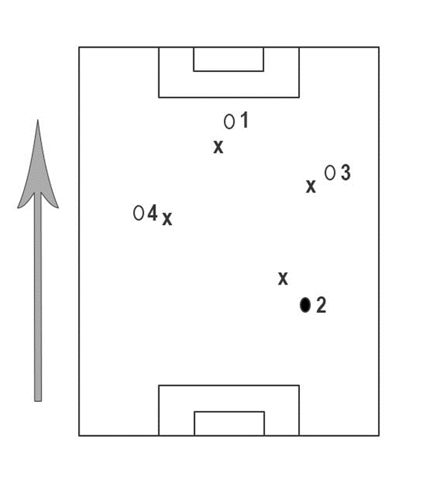
Write a statement to explain the positioning of your teammates. Explain your decisions and player movements to show your understanding of the correct attacking option based on the situation.

Signed:

Year 8 invasion game – solving a tactical problem

Teacher marking criteria (Teacher assessment)
Criteria | Outstanding  A | High  B | Sound  C | Basic  D | Needs improvement  E
Overall | Students demonstrate extensive knowledge and understanding when solving tactical problems in invasion games. | Students demonstrate thorough knowledge and understanding when solving tactical problems in invasion games. | Students demonstrate sound knowledge and understanding when solving tactical problems in invasion games. | Students demonstrate basic knowledge and understanding when solving tactical problems in invasion games. | Students demonstrate elementary knowledge and understanding when solving tactical problems in invasion games.
Attacking position | Students demonstrate a very high level of understanding of the correct attacking option in the given situation. | Students demonstrate a high level of understanding of the correct attacking option in the given situation. | Students demonstrate understanding of the correct attacking option in the given situation. | Students demonstrate limited understanding of the correct attacking option in the given situation. | Students demonstrate elementary understanding of the correct attacking option in the given situation.
Justification | Students are able to provide an extensive justification of their decisions and player movements within the scenario. | Students are able to provide a thorough justification of their decisions and player movements within the scenario. | Students are able to provide a sound justification of their decisions and player movements within the scenario. | Students are able to provide a basic justification of their decisions and player movements within the scenario. | Students are able to provide an elementary justification of their decisions and player movements within the scenario.

